**Algorithm and Programming Final Project Report**

**Name of Lecturer: Jude Joseph Lamug Martinez, MCS**

**Made by:**

Farrell Raffelino Sunarman (2802503476)

**BINUS UNIVERSITY INTERNATIONAL JAKARTA**

**2025**

# TABLE OF CONTENTS

TABLE OF CONTENTS 2

Chapter 1 3

* 1. Project Description 3
  2. Project Link 3
  3. Essential Algorithm 3
  4. Modules 7

Chapter 2 8

* 1. Use Case Diagram 8
  2. Activity Diagram 9
  3. Class Diagram 10

Chapter 3 11

* 1. Screenshots 11
  2. Video Demo 14

Chapter 4 15

* 1. Lessons Learnt 15
  2. Future Improvements 15

## Chapter 1

**PROJECT SPECIFICATIONS**

### Project Description

For my final project, I re-created the infamous puzzle created by a “French Mathematician, Édouard Lucas in 1833 (Scientific American)”, The Tower of Hanoi as a game. I had thought about creating my own assets and visuals, but after further research, I decided to use assets that can be made through the pygame function.

The game starts with a menu screen where the player is able to choose a difficulty ranging from 1-6 (Higher the number, the more discs that is on the tower), then press ENTER to start the game. When starting the game, the player will see 3 towers and on the first tower the number of discs they have selected when choosing the game’s difficulty. Using their “high” logical and intelligent brain, the player make optimal moves to get all the discs from the first tower to the third tower, having the biggest disc on the bottom and smaller towards the top. Once all discs are in the third tower, the player is awarded with stars depending on their performance.

### Project Link

The Final Project can be accessed through the GitHub Repository provided below:

<https://github.com/Shuu165/AlgoPro-Finale>

### Essential Algorithm

* + 1. Difficulty Selection:
       - Using the Arrow Keys to switch between Difficulties (1-6)
    2. Pointer:
       - Draws a Red Arrow
       - Follows Moving Discs when picked up
    3. Disc Size:
       - Determine the disc size
       - Place the discs on the tower from biggest on the base to smallest going towards the top
    4. Arrow Key Movement:
       - Left and Right keys to move the discs left and right to change position/tower
       - Up and Down keys to Pick up or Put down a disc on a tower
       - Uses PyGame’s event.get()
    5. Size Placement Checker:
       - Checks if the current disc is smaller/larger than the disc on the bottom
       - If Smaller, It’s valid and will be able to be placed down
       - If Bigger, It’s not valid and cannot be placed
    6. Timer:
       - Count starts at 0 and gradually increases by 1 the more time passes
    7. Star System:
       - Give player stars upon completing certain requirements. 1 star as completion, another when completed using the most minimal amount of steps (Uses the Tower of Hanoi’s algorithm to determine each difficulty’s most minimal steps), and last star when done below the timer (set on 5 minutes)

### Modules

* + 1. PyGame:

The base and foundation of the program. Without the use of it, the game would be very minimally text-based. It allowed the creation of GUI, images, and audio in our program to make it more lively.

* + 1. Sys Module:

It is used to close the PyGame program using the sys.exit() function

* + 1. Timer Module:

It is used for the Timer aspect of the game

# Chapter 2

**SOLUTION DESIGN**

### Use Case Diagram

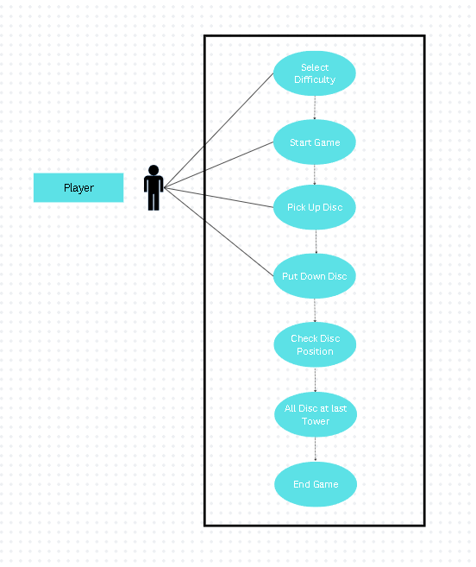

### Activity Diagram

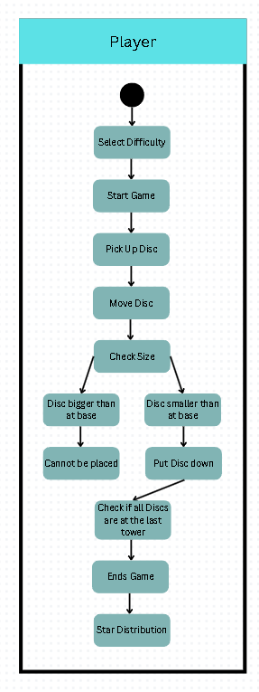

### Class Diagram

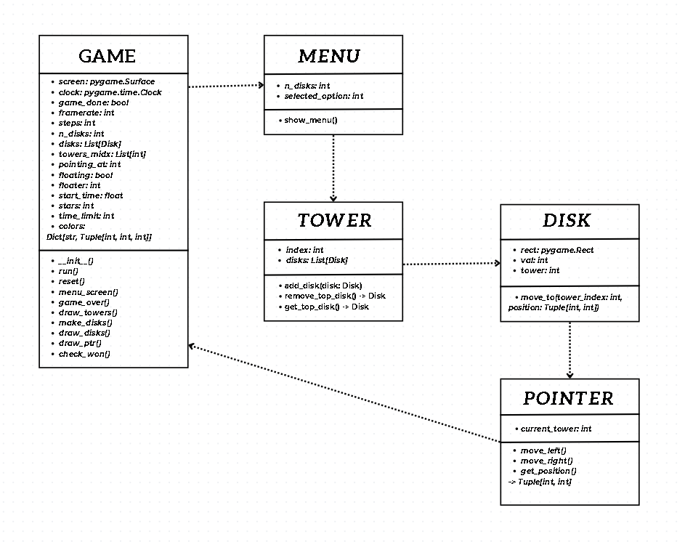

* 1. **Screenshots**

**Menu:**

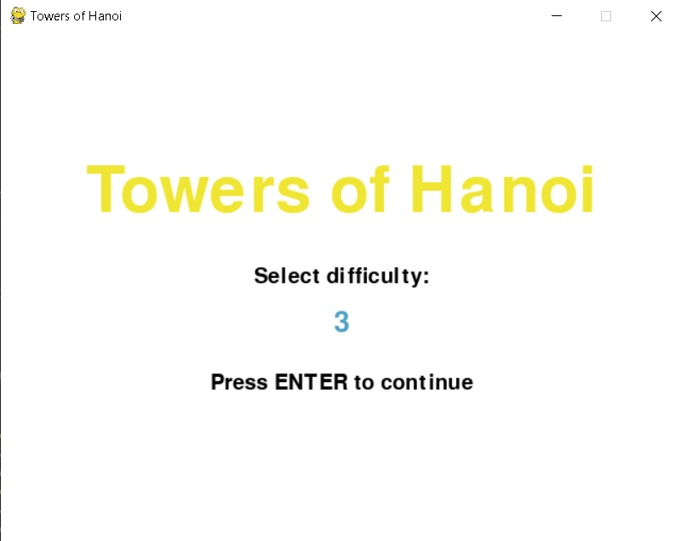

**Start:**

# Chapter 3

**DOCUMENTATION**

**Pick Up discs:**

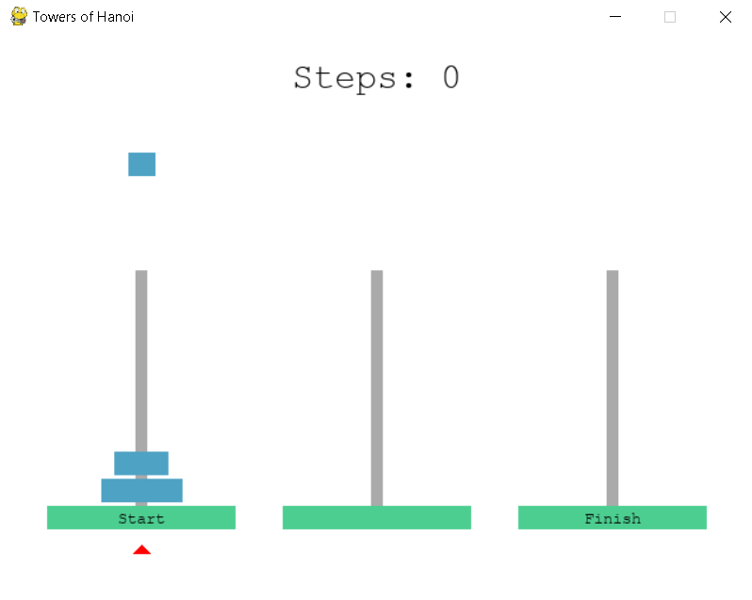

**Game Fin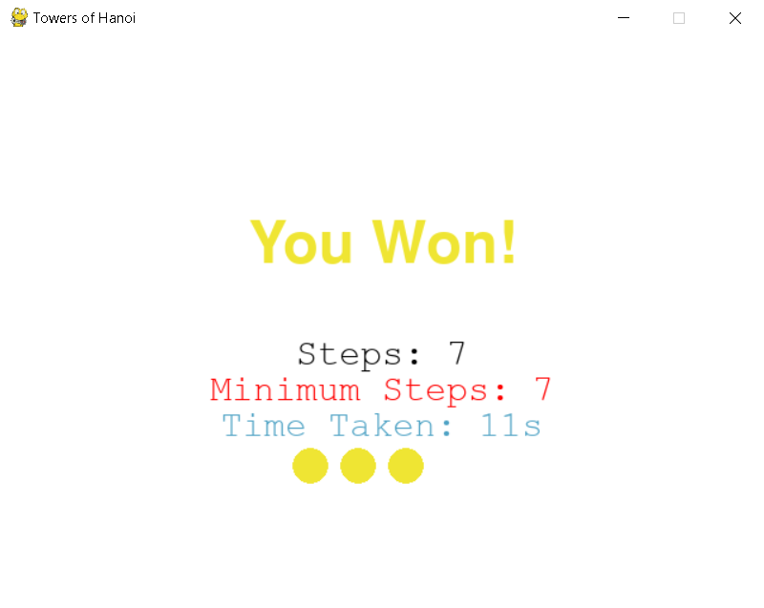ish:**

### Video Demo

The link below is a Google Drive where I have uploaded my Video Demo:

<https://drive.google.com/drive/folders/1cexbMus9j7C5lcQeS_NF7fNwf4PAgVMV?usp=sharing>

# Chapter 4

**EVALUATION AND REFLECTION**

### Lessons Learnt

During the time I spent working on this Final Project, I have learnt a lot more and gained the experience that I have been lacking. Learnt how to program using the Python language as it is my first time using it, how to use functions like classes and variables in my program to be able to make a simple game, learning how to think outside of the box and do things out of my comfort zone whenever a problem occurs.

With a lot of research and many sleepless nights, I further understood on what certain functions do and how to implement it in my code and ideas, the basics of game-making and linking them all into one full working program.

Time-management is something I always have been lacking, but through this project, I have been able to have better management with my time in working in this Final-Project, getting everything done one step at a time.

### Future Improvements

I could have easily been a bit more ambitious when it came to the theme and idea of my project but in the end I decided to take a much simpler route, and that is definitely something I can improve on a bit more, as to think and put in a bit more effort to be able to create something that I will be satisfied with outside of my comfort zone, something I could reflect on and to always strive for better.

I

I also did not implement a main menu. The main menu is one of the most important aspects of a game which I skipped entirely as, for some reason I was not able to make it work, even after I tried multiple different methods in handling game states, which was why I didn’t implement it.

Some other things that I could’ve implemented but are only there for the

aesthetics are animations. For example, an animation for pulling up the camera monitor, or for the door being closed. There are a lot of things that are meant to be animated within the game’s screen. However, I only figured out how to properly get them to work on the last day and therefore, I was only able to implement several of the more important animations like the jumpscares.

Overall, there is still so much more room for improvement for my project. But even knowing this, I am very satisfied with what I was able to make within such a tight time frame, even if it is only a remake of an already existing game and not at all an original idea with original assets.